Free Root

What is Free Root
# Source: AI Source: Provided by: [Data Path: Persons Table -> ID Column: 1, Name_En Column: Motasem Essam] -> From: [Chatgpt (GPT-4-turbo)] on [7/29/2025]
A free root is a type of root morpheme that can stand alone as a complete word without needing to be attached to any other morphemes. It carries meaning on its own and can function independently in speech and writing.

🔹 Definition of Free Root:
# Source: AI Source: Provided by: [Data Path: Persons Table -> ID Column: 1, Name_En Column: Motasem Essam] -> From: [Chatgpt (GPT-4-turbo)] on [7/29/2025]
A free root (also called a free morpheme) is a morpheme that can stand alone as a word. It is the base to which affixes (prefixes, suffixes) may be added to create new words.

🔹 Examples of Free Roots:
# Source: AI Source: Provided by: [Data Path: Persons Table -> ID Column: 1, Name_En Column: Motasem Essam] -> From: [Chatgpt (GPT-4-turbo)] on [7/29/2025]
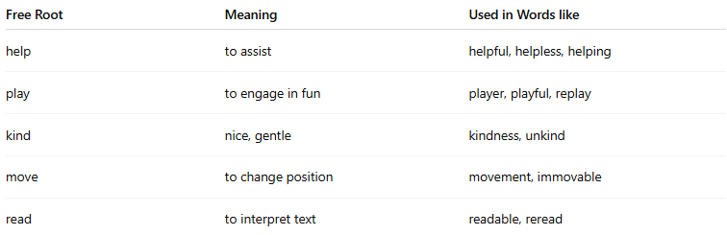
Free Root | Meaning | Used in Words like
help | to assist | helpful, helpless, helping
play | to engage in fun | player, playful, replay
kind | nice, gentle | kindness, unkind
move | to change position | movement, immovable
read | to interpret text | readable, reread
Each of the examples above is a word on its own (free root) and can take affixes to form new words.

🔹 Features of Free Roots:
# Source: AI Source: Provided by: [Data Path: Persons Table -> ID Column: 1, Name_En Column: Motasem Essam] -> From: [Chatgpt (GPT-4-turbo)] on [7/29/2025]
- ✅ Can function as independent words.
- ✅ Can combine with affixes to form derived or inflected words.
- ✅ Always carry lexical meaning (i.e., they are content words like nouns, verbs, adjectives, etc.).
- ❌ Not all root morphemes are free—some are bound roots, which cannot stand alone.

🔹 Free Root vs. Bound Root:
# Source: AI Source: Provided by: [Data Path: Persons Table -> ID Column: 1, Name_En Column: Motasem Essam] -> From: [Chatgpt (GPT-4-turbo)] on [7/29/2025]
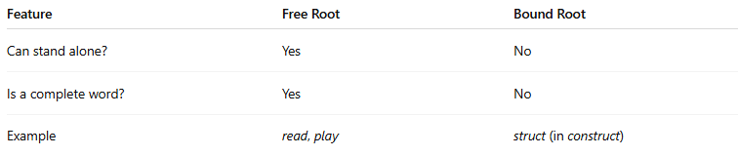
Feature | Free Root | Bound Root
Can stand alone? | Yes | No
Is a complete word? | Yes | No
Example | read, play | struct (in construct)

